**• Explain React events**

**Ans.** React events are JavaScript events that behave similarly to DOM events but are wrapped in React’s cross-browser wrapper called **SyntheticEvent**.



Here, onClick is a React event.

**• Explain about event handlers**

**Ans.** These are functions that get triggered when an event occurs.

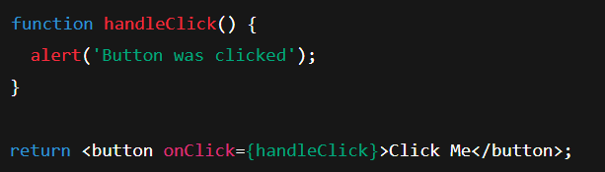handleClick is the event handler function.

**• Define Synthetic event**

**Ans.** A SyntheticEvent is a wrapper around the browser’s native event, provided by React to ensure cross-browser consistency.

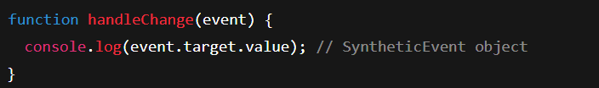

**• Identify React event naming convention**

**Ans.** camelCase